Amit Charran

Day 1 Assignment 4

1) The original function is f(x) = 0.5x + 2. The new function, g(x) is the equation of f(x) after a reflection across the y-axis and a vertical stretch with a constant of 2.5. What is the equation of g(x)?



The reflection of f(x) on the y-axis is f(-x)

The 2.5 vertical stretch of f(x) is 2.5(f(x))

First lets do the reflection

Replace x with -x

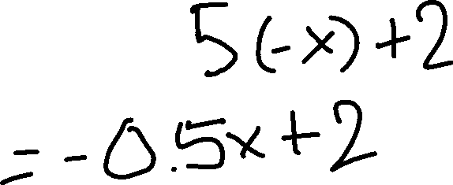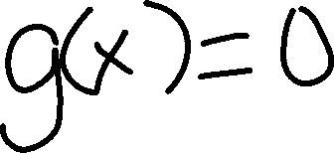

Now lets do the vertical stretch by multiplying the whole equation by 2.5

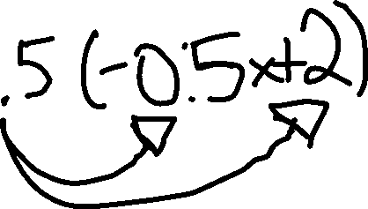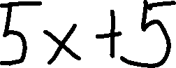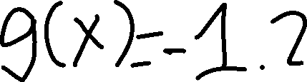

So the answer is

g(x) = -1.25x + 5

2) What type of function does the following table create? What is the shape of its graph?

|  |  |
| --- | --- |
| X | y |
| -1 | 3 |
| 0 | 2 |
| 1 | 3 |
| 2 | 6 |

To find the shape, first plot the points

(-1,3), (0,2), (1,3), (2,6)



From the shape of the graph this is a parabola and it is quadratic

3) Maria orders T-shirts for her volleyball camp. Adult-sized T-shirts cost $6.25 each and youth-sized T-shirts cost $4.50 each. Maria has $550 to purchase both adult-sized and youthsized T-shirts. If she purchases 45 youth-sized T-shirts, determine algebraically the maximum number of adult-sized T-shirts she can purchase.



The first thing we should do is create correct labels for our equation. Create the labels however you want.

Price of Adult sized T-shirt = 6.25

Lets label

Number of Adult sized T-shirt = x

Price of youth-sized T-shirt = 4.50

Lets label

Number of Youth sized t-shirt = y (45)

Total Money = $550

Number of youth sized t-shirt bought = 45

Now we need to create the equation to answer the question. To find out how many number adult sized t-shirts Maria can buy.

So use words helps a lot.

“Total Money” <= (“Number of youth sized t-shirt” * 4.50) + (“Number of adult sized t-shirts”* 6.25)

So if we replace with our values we get

550 <= (45)*4.50 + 6.25x

Now solve for x

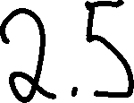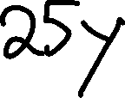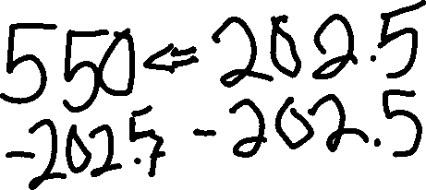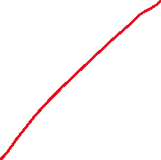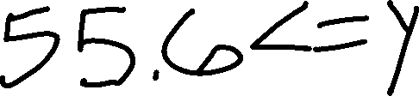

55.6 <= y

So the answer is 55.

Maria can buy at most 55 Adult sized T-shirts

4) The math department needs to buy new textbooks and laptops for the computer science classroom. The textbooks cost $116.00 each, and the laptops cost $439.00 each. If the math department has $6500 to spend and purchases 30 textbooks, how many laptops can they buy?

First lets create labels for our equations.

Price of textbooks = 116

Number of textbooks = x(30)

Price of computers = 439

Number of computers = y

Total Money = 6500

Number of textbooks bought = 30

Lets create the equation.

“Total Money” = (“price of textbooks” * “number of textbooks”) + (“price of computers” * “number of computers”)

Substitute values

6500 <= 116(30) + 439y

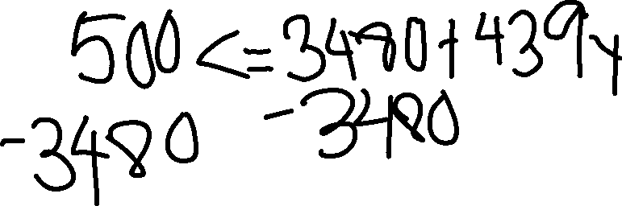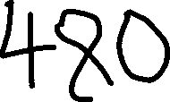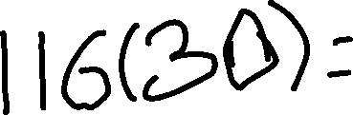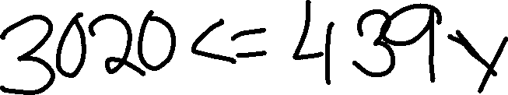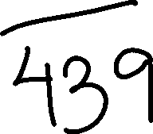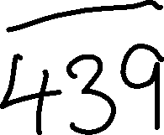

So after all the textbooks, we can only buy 6 computers.

5) Solve algebraically for x: 3600 + 1.02x < 2000 + 1.04x

